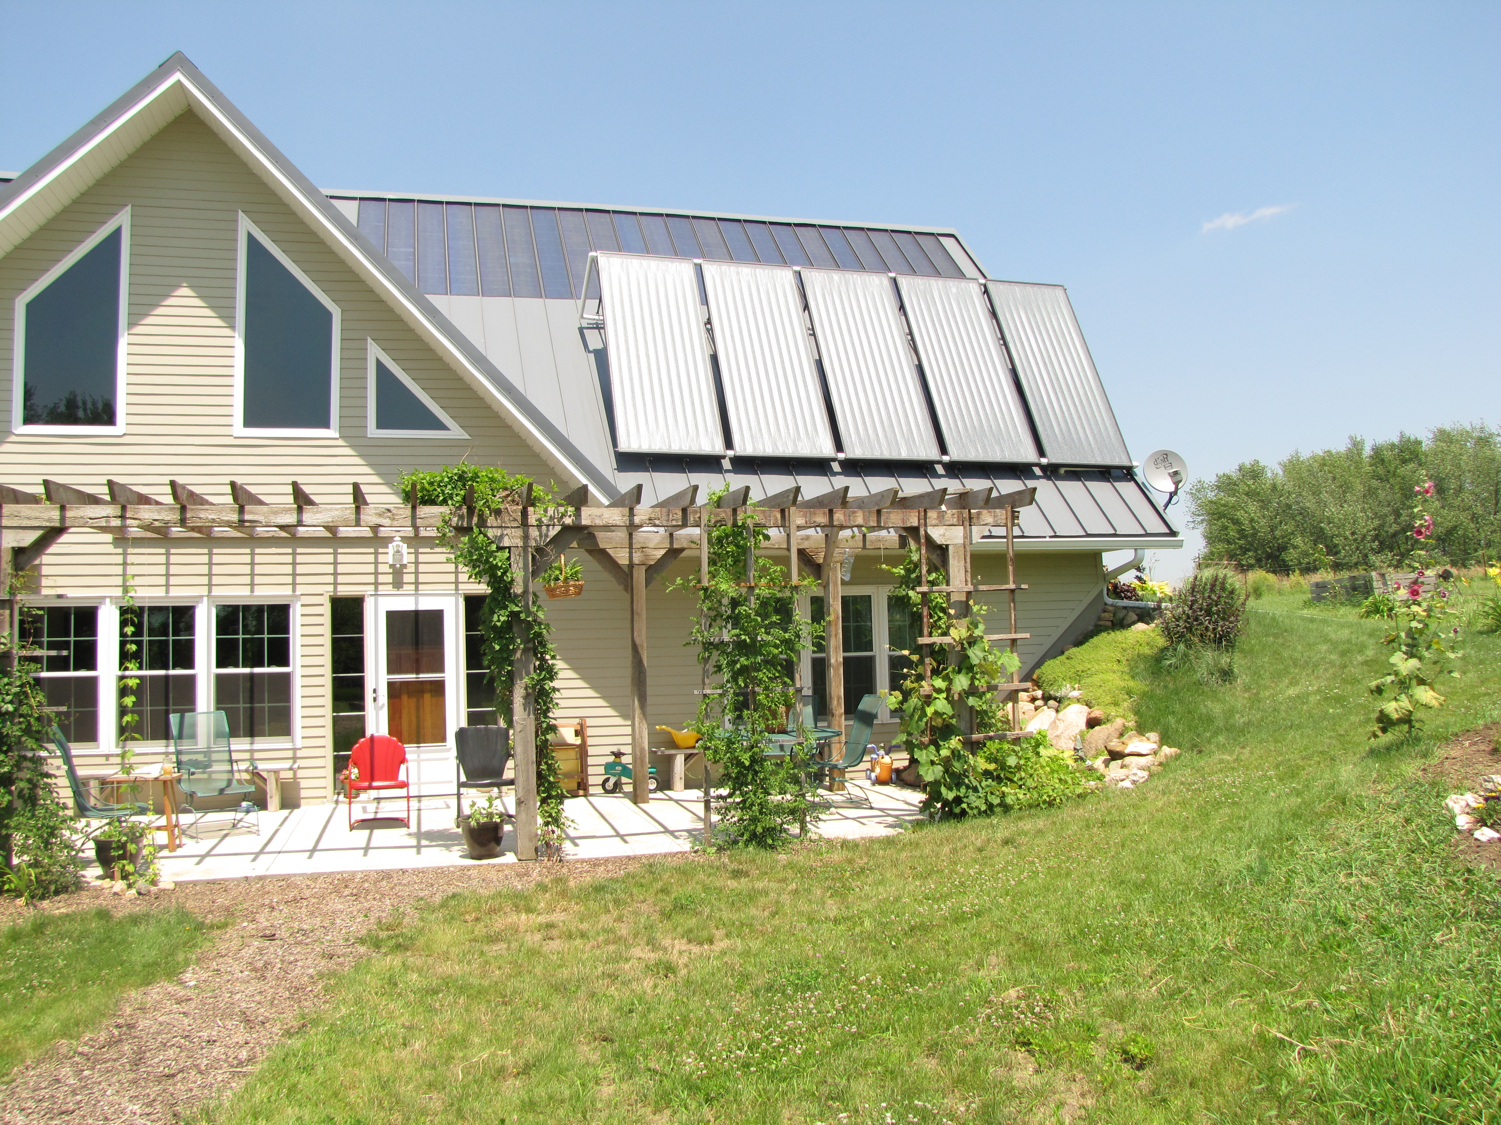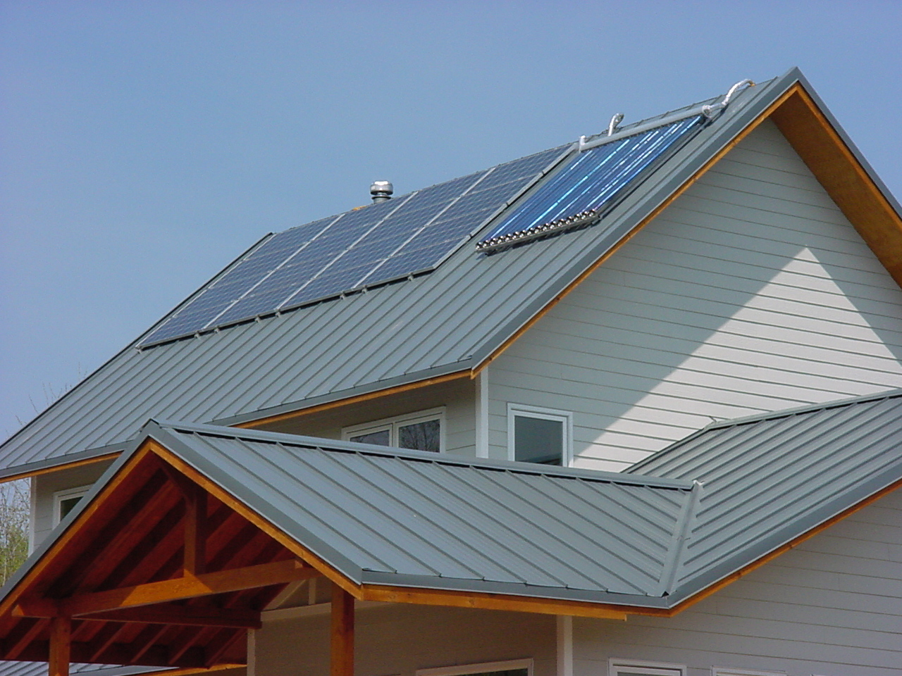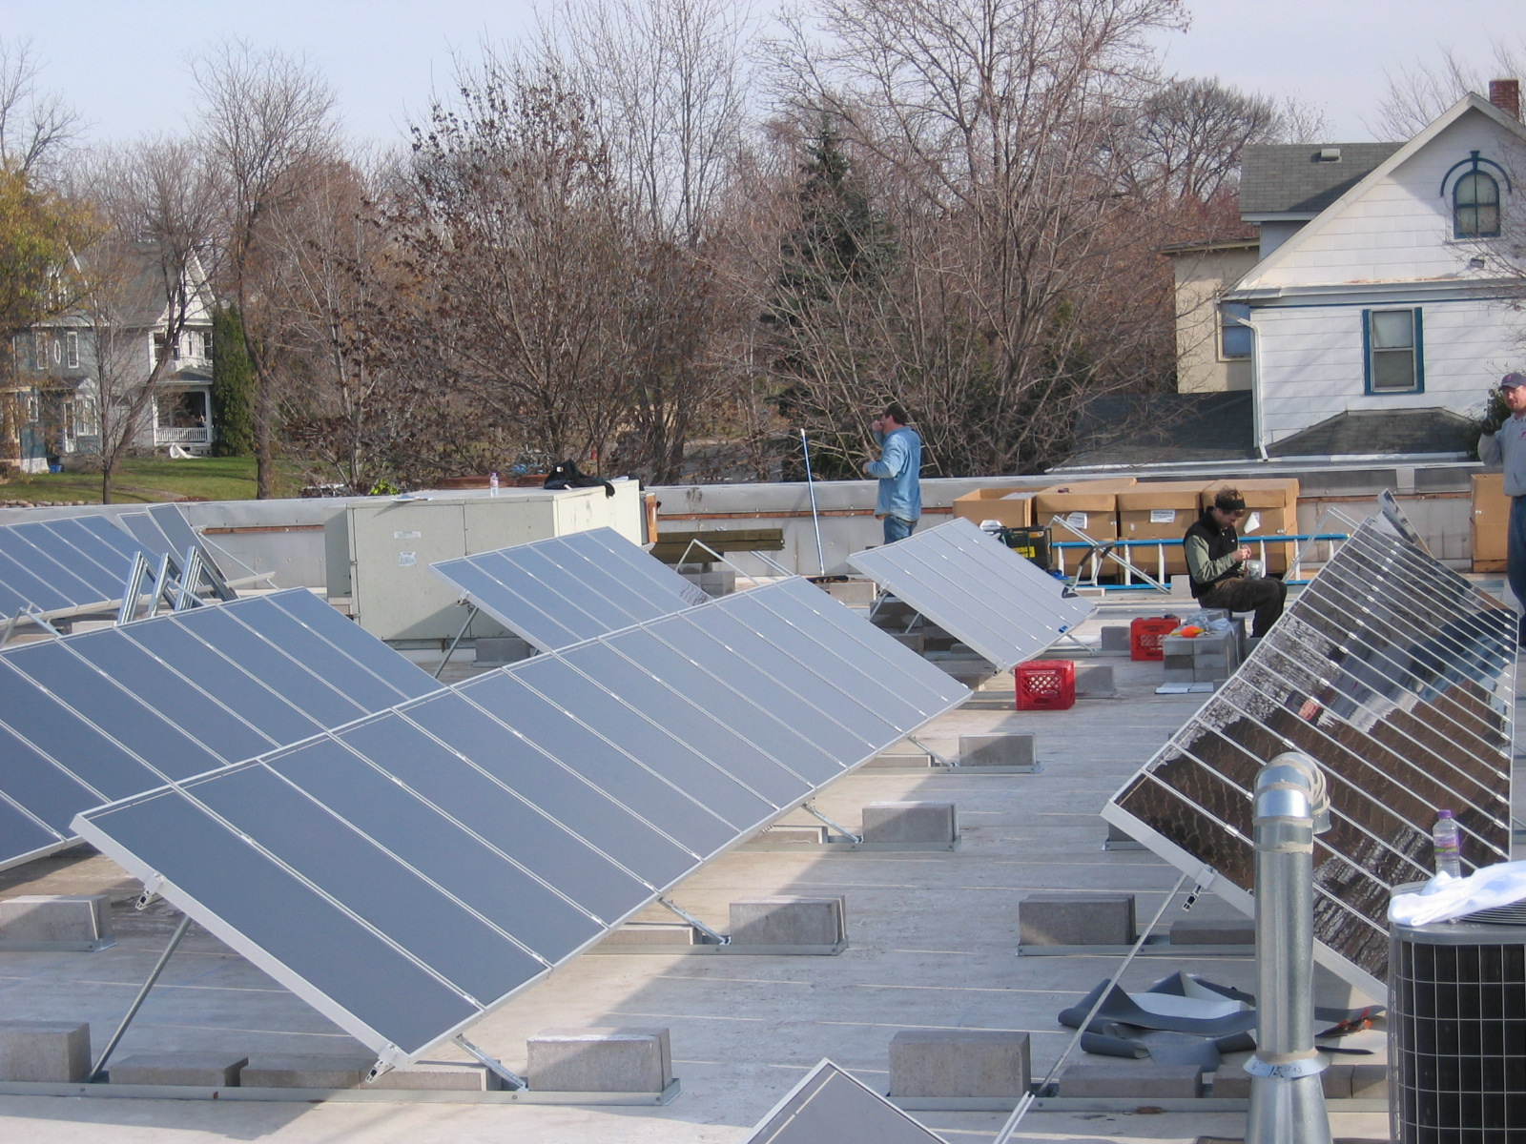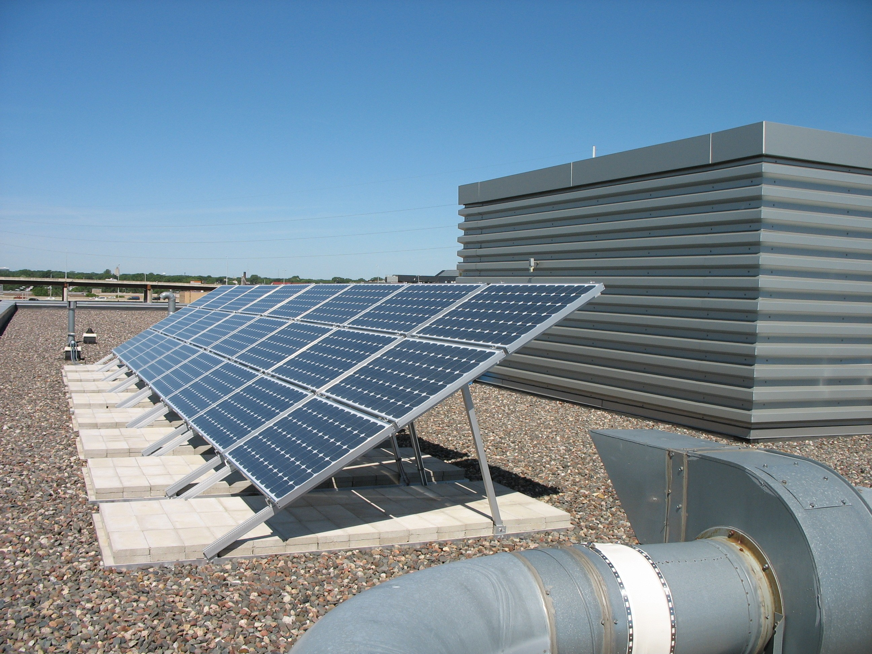

Minnesota Solar Ready
Construction Specification
To be used in conjunction with the
Solar Ready Building Design Guidelines

Produced for the Minneapolis Saint Paul Solar Cities Program
By Lunning Wende Associates

This page is intentionally left blank

SECTION 017500

SOLAR READY CONSTRUCTION REQUIREMENTS

These Construction Specifications and the Solar Ready Building Design Guidelines are companion documents to be used together. Starting with the Design Guidelines in the initial stages of project planning and the finalization of building design, the Owner and Building Team make decisions informing the construction process. The Construction Specifications, along with the Drawings and other specification sections, document these decisions so that Solar Ready systems can be easily incorporated during the construction process.

The purpose of this Section is to establish responsibilities and procedures for the provision of Solar Ready Construction shown in the Contract Documents, i.e. Drawings and Specifications.

The Specifier should edit this section to the specific requirements of the Project.

PART 1 GENERAL

  - INTENT AND CONDITIONS

- Intent
  - Define and coordinate the scope of the Solar Ready Construction.
  - Assure that the specified elements of the Solar Ready system are installed in compliance with 2006 International Building Code (IBC) as adopted by the current Minnesota State Building Code, National Electrical Code, and other applicable state and local regulations.
  - Inspections are intended to assist in meeting the requirements for Solar Ready Construction and do not relieve the Contractor of responsibility for compliance with the requirements of the contract documents.

- Conditions
  - The Project is designed to allow the future installation of a [photovoltaic] [solar thermal] generation system.
  - [Describe the scope of the Solar Ready Construction components and list related specification sections, if applicable.]
  - Refer to individual specification sections and to the drawings for specific requirements.
  - Work will be checked as it progresses and deficiencies will be corrected in a timely manner.

  - REQUIREMENTS

- The Owner requires this project be made ready for the future installation of the solar power generation systems described in the Contract Documents.
- Coordinate the General Construction, Structural, Mechanical, and Electrical elements of the Solar Ready Construction with the Work.
- Required Solar Ready Construction elements, as specified or shown in the Drawings: [Edit the list below to Specific Project Requirements.]
  - Roof Space, free of obstructions, reserved for Solar Array.
  - Roof Space Structure to support Solar Array.
  - Mounting System at Roof for attachment of Solar Array
  - Special Roofing System requirements.
  - Special construction— [chases,] [conduits,] [piping,] [specify other]—required for future connections between the solar array and remote system components.
  - Special Electrical requirements.
  - Special Plumbing requirements.

  - DEFINITIONS

- Solar Ready Construction: All elements of the Work required to prepare a building for the future installation of a solar system. This may include a mounting system, special roof structure requirements, space allocations on the roof and within the building, conduits, chases, and piping to receive future wiring or plumbing, and electrical service components.
- Photovoltaic (PV) System: Photovoltaic systems convert the sun’s energy to electricity. For additional information:http://www1.eere.energy.gov/solar/photovoltaics.html
- Solar Thermal (ST) System: Solar thermal systems use the sun’s energy to provide hot water and/or space heating. For additional information: http://www1.eere.energy.gov/solar/solar_heating.html
- Solar Module: Each of a set of independent solar panels that can be combined to make up a solar array.
- Solar Array: A set of individual solar panels arranged to function as a single unit.
- Mounting System: stand-off mounts secured to the roof to support the future solar array.
- Roof Space: Assigned roof area to receive the future solar array.
- Obstructions: Roof projections casting shadows or projecting into the
- Structure at Roof Space: Special structural requirements to support solar array loads, wind and snow loads.
- Inverter: An apparatus that converts direct current (DC) into alternating current (AC).
- Solar Electric Feed: Electrical connection from the photovoltaic array to the inverter.
- Storage Tank: Fluid storage component of a solar thermal system.
- Sensor Wire: Low voltage connection from solar thermal array to system monitor.
- Inspector(s): A party or parties designated by the Owner to perform the responsibilities described in Section 017500 - 1.04.B.
[Edit definitions, if applicable.]

  - REFERENCES

- Solar Ready Buildings Planning Guide, National Renewable Energy Laboratory, Technical Report NREL/TP-7A2-46078, 2009.
- Solar Thermal & Photovoltaic Systems, Building America Best Practices Series, Vol. 6, Pacific Northwest National Laboratory & Oak Ridge National Laboratory, NREL/TP-550-41085, 2007.
- U.S. Department of Energy Solar Energy Technologies Program website: http://www1.eere.energy.gov/solar/technologies.html
- Expedited Permit Process for PV Systems, Solar America Board for Codes and Standards, New Mexico State University, 2009
- Building a Solar Ready Home Technical Guidelines, Canadian Solar Industries Association, 2007
[Add references, if applicable.]

  - RESPONSIBILITIES

[Edit the list below for Specific Project Requirements.

[Note: Architect, Engineer, and/or others, as part of standard services, may assume Inspector’s responsibilities.

Inspector’s responsibilities may be divided among parties having expertise in specific aspects of the work. Designate parties and stipulate the division of work and responsibilities, if applicable.]

- Owner:

  - Establish funding to provide for the cost of inspection of the Solar Ready Construction system components.
  - Designate an inspector for the complete Solar Ready Construction system.
  - Provide inspector with approved drawings, specifications, and shop drawings.
  - Provide inspector with access to the job site at all times.
  - Sign the attached Acknowledgement Checklist in conjunction with other parties.

- Inspector:

  - Sign the attached Acknowledgement Checklist in conjunction with other parties.
  - Review approved drawings, specifications, and shop drawings pertaining to the Solar Ready Construction system components.
  - Attend pre-construction meeting to review scope of Solar Ready Construction system requirements with all parties.
  - Coordinate
  - Inspect the work in a timely manner and bring nonconforming work to the immediate attention of the Contractor. Re-inspect nonconforming work for compliance.
  - Submit inspection reports to the Owner, Contractor, [Architect,] [Engineer,] and Building Official within 48 hours of each inspection visit.

- Contractor:

  - Prepare and sign the attached Acknowledgement Checklist and maintain a copy at the job site.
  - Attend pre-construction meeting to review scope of Solar Ready Construction system requirements. Require the attendance of relevant subcontractors at the pre-construction meeting.
  - Provide labor and materials to accomplish the Solar Ready Construction requirements.
  - Coordinate the work of all parties to assure Solar Ready elements are installed properly and inspected prior to covering or enclosing the Work.
  - Verify conformance of the Work to Solar Ready Construction requirements.
  - Provide inspecting [Architect] [Engineer] [Solar Consultant] [Owner] [Owner-designated Representative] safe access to the site for inspection of the Work and project documentation at the job site.
  - Review reports prepared by [Architect] [Engineer] [Solar Consultant] [Owner] [Owner-designated Representative].
  - Correct deficiencies identified in the inspection reports.

  - INSPECTION NOTICE

The Contractor shall provide the Inspector with a preliminary schedule and updated schedule for the work and shall inform the Inspector of

  - REPORTS

- The Inspector shall submit inspection reports in a timely manner to the Contractor, Owner, [Other; designate.] and Building Official.
- Provide reports containing the following information:

  - Date issued.
  - Project name and location.
  - Inspector’s name and contact information.
  - Date of inspection.
  - System components inspected.
  - Deficiencies observed in the work.
  - Direction for correcting deficiencies.

  - PROTECTION AND REPAIR

- Upon completion and inspection of the each element of the Solar Ready Construction system, the Contractor shall maintain the system components to the conditions as approved. Deficiencies in system components that develop following inspection and approval shall be brought to the immediate attention of the inspector. Protection and repair is the Contractor’s responsibility.
SOLAR READY CONSTRUCTION REQUIREMENTS ACKNOWLEDGEMENT
Project: |  |  |  |  |  | Project No.:
Location:
Permit No:
SOLAR READY CONSTRUCTION INSPECTION SCHEDULE
Description of Work |  | Pre-Construction Meeting |  | Inspection #1 |  | Re-inspection, if needed. #1 |  | Acknowledgement #2 |  | Acknowledgement #2
Framing |  | Prior to beginning of Framing
Roofing |  | Prior to Roofing installation
Finishing |  | Prior to beginning of Wall Finishing
Plumbing |  | Prior to Plumbing rough-in
Electrical |  | Prior to Plumbing rough-in
Note: Schedule is to be filled out during construction.
#1 |  | Inspector shall initial and date following each inspection.
#2 |  | Contractor shall initial and date following acceptance of the work by the Inspector.
Contractor and Inspector(s) to sign and date:
Contractor: |  |  |  |  |  |  |  | Date:
Framing Insp.: |  |  |  |  |  |  |  | Date:
Roofing Insp.: |  |  |  |  |  |  |  | Date:
Finishing Insp.: |  |  |  |  |  |  |  | Date:
Plumbing Insp.: |  |  |  |  |  |  |  | Date:
Electrical Insp.: |  |  |  |  |  |  |  | Date:
Architect: |  |  |  |  |  |  |  | Date:
Owner: |  |  |  |  |  |  |  | Date:

